1. Program to perform arithmetic operations (Addition, Subtraction, Multiplication, Division) on two numbers?

ANS:

#include <stdio.h>

int main() {

int num1, num2;

printf("Enter two numbers: ");

scanf("%d %d", &num1, &num2);

printf("Addition: %d\n", num1 + num2);

printf("Subtraction: %d\n", num1 - num2);

printf("Multiplication: %d\n", num1 * num2);

if (num2 != 0) {

printf("Division: %.2f\n", (float)num1 / num2);

} else {

printf("Division: Undefined (cannot divide by zero)\n");

}

return 0;

}

OUTPUT:

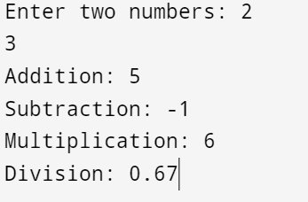

2. Program to calculate gross salary of an employee [using formula: gross_sal = basic_sal + hra + da]

#include <stdio.h>

int main() {

float basic_sal, hra, da, gross_sal;

printf("Enter basic salary: ");

scanf("%f", &basic_sal);

printf("Enter HRA: ");

scanf("%f", &hra);

printf("Enter DA: ");

scanf("%f", &da);

gross_sal = basic_sal + hra + da;

printf("Gross Salary: %.2f\n", gross_sal);

return 0;

}

Output

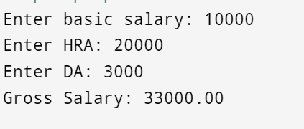

3. Program to find the sum and reverse of a three-digit number

#include <stdio.h>

int main() {

int num, sum = 0, reverse = 0, digit;

printf("Enter a three-digit number: ");

scanf("%d", &num);

int temp = num; // To calculate the sum of digits

while (temp > 0) {

digit = temp % 10;

sum += digit;

reverse = reverse * 10 + digit;

temp /= 10;

}

printf("Sum of digits: %d\n", sum);

printf("Reverse of the number: %d\n", reverse);

return 0;

}

Output:

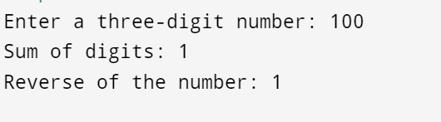

4. Program to swap two numbers without using a third variable

#include <stdio.h>

int main() {

int num1, num2;

printf("Enter two numbers: ");

scanf("%d %d", &num1, &num2);

printf("Before swapping: num1 = %d, num2 = %d\n", num1, num2);

num1 = num1 + num2; // Sum both numbers

num2 = num1 - num2; // Assign difference to num2 (original num1)

num1 = num1 - num2; // Assign difference to num1 (original num2)

printf("After swapping: num1 = %d, num2 = %d\n", num1, num2);

return 0;

}

Output:

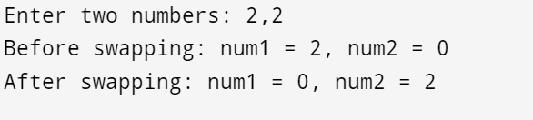

5. Program to print a table of any number

#include <stdio.h>

int main() {

int num, i;

printf("Enter a number: ");

scanf("%d", &num);

printf("Table of %d:\n", num);

for (i = 1; i <= 10; i++) {

printf("%d x %d = %d\n", num, i, num * i);

}

return 0;

}

Output:

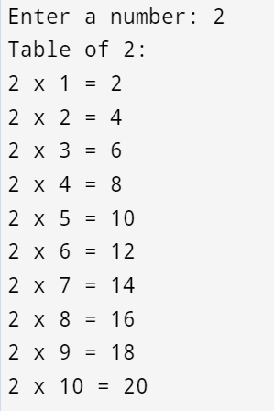

6. Program to find the greatest among 3 numbers

#include <stdio.h>

int main() {

int num1, num2, num3;

printf("Enter three numbers: ");

scanf("%d %d %d", &num1, &num2, &num3);

if (num1 >= num2 && num1 >= num3)

printf("Greatest number is: %d\n", num1);

else if (num2 >= num1 && num2 >= num3)

printf("Greatest number is: %d\n", num2);

else

printf("Greatest number is: %d\n", num3);

return 0;

}

Output:

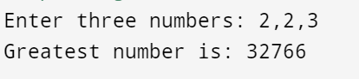

7. Program to find if an entered year is a leap year or not

#include <stdio.h>

int main() {

int year;

printf("Enter a year: ");

scanf("%d", &year);

if ((year % 4 == 0 && year % 100 != 0) || (year % 400 == 0))

printf("%d is a leap year.\n", year);

else

printf("%d is not a leap year.\n", year);

return 0;

}

Output:

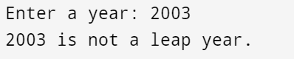

8. Program to find whether a given number is even or odd

#include <stdio.h>

int main() {

int num;

printf("Enter a number: ");

scanf("%d", &num);

if (num % 2 == 0)

printf("%d is even.\n", num);

else

printf("%d is odd.\n", num);

return 0;

}

Output:

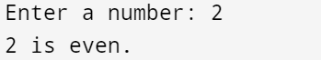

9. Program to find the roots of a quadratic equation

The formula for the roots of is:

Root 1 =

Root 2 =

#include <stdio.h>

#include <math.h>

int main() {

float a, b, c, discriminant, root1, root2, realPart, imaginaryPart;

printf("Enter coefficients a, b, and c: ");

scanf("%f %f %f", &a, &b, &c);

discriminant = b * b - 4 * a * c;

if (discriminant > 0) {

root1 = (-b + sqrt(discriminant)) / (2 * a);

root2 = (-b - sqrt(discriminant)) / (2 * a);

printf("Roots are real and different.\n");

printf("Root 1 = %.2f\n", root1);

printf("Root 2 = %.2f\n", root2);

}

else if (discriminant == 0) {

root1 = root2 = -b / (2 * a);

printf("Roots are real and same.\n");

printf("Root 1 = Root 2 = %.2f\n", root1);

}

else {

realPart = -b / (2 * a);

imaginaryPart = sqrt(-discriminant) / (2 * a);

printf("Roots are complex and different.\n");

printf("Root 1 = %.2f + %.2fi\n", realPart, imaginaryPart);

printf("Root 2 = %.2f - %.2fi\n", realPart, imaginaryPart);

}

return 0;

}



10. Program to use switch statement to display days of the week

#include <stdio.h>

int main() {

int day;

printf("Enter a day number (1-7): ");

scanf("%d", &day);

switch (day) {

case 1:

printf("Monday\n");

break;

case 2:

printf("Tuesday\n");

break;

case 3:

printf("Wednesday\n");

break;

case 4:

printf("Thursday\n");

break;

case 5:

printf("Friday\n");

break;

case 6:

printf("Saturday\n");

break;

case 7:

printf("Sunday\n");

break;

default:

printf("Invalid day number!\n");

}

return 0;

}

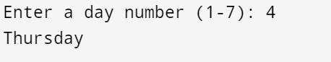

11. Program to calculate the power of a number using #DEFINE

#include <stdio.h>

#define POWER(x, y) (pow(x, y))

int main() {

int base, exponent;

double result;

printf("Enter base and exponent: ");

scanf("%d %d", &base, &exponent);

result = POWER(base, exponent);

printf("%d raised to the power %d is %.2f\n", base, exponent, result);

return 0;

}

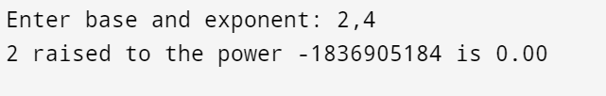

12. Program to display first 10 natural numbers and their sum

#include <stdio.h>

int main() {

int sum = 0;

printf("First 10 natural numbers: ");

for (int i = 1; i <= 10; i++) {

printf("%d ", i);

sum += i;

}

printf("\nSum of first 10 natural numbers: %d\n", sum);

return 0;

}

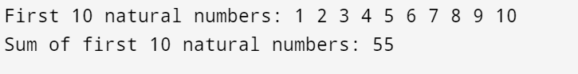

13. Program to find the factorial of a number

#include <stdio.h>

int main() {

int num, factorial = 1;

printf("Enter a number: ");

scanf("%d", &num);

for (int i = 1; i <= num; i++) {

factorial *= i;

}

printf("Factorial of %d is %d\n", num, factorial);

return 0;

}

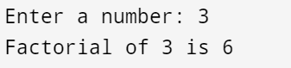

14. Program to generate the Fibonacci series up to n terms

#include <stdio.h>

int main() {

int n, t1 = 0, t2 = 1, nextTerm;

printf("Enter the number of terms: ");

scanf("%d", &n);

printf("Fibonacci Series: ");

for (int i = 1; i <= n; i++) {

printf("%d ", t1);

nextTerm = t1 + t2;

t1 = t2;

t2 = nextTerm;

}

printf("\n");

return 0;

}

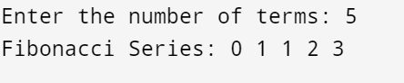

15. Program to print stars sequence

#include <stdio.h>

int main() {

int n;

printf("Enter the number of rows: ");

scanf("%d", &n);

for (int i = 1; i <= n; i++) {

for (int j = 1; j <= i; j++) {

printf("*");

}

printf("\n");

}

return 0;

}

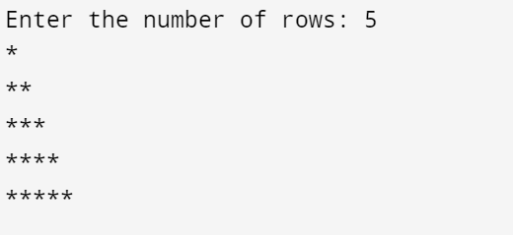

16. Program to check whether a given number is palindrome or not

#include <stdio.h>

int main() {

int num, original, reversed = 0, remainder;

printf("Enter a number: ");

scanf("%d", &num);

original = num;

while (num != 0) {

remainder = num % 10;

reversed = reversed * 10 + remainder;

num /= 10;

}

if (original == reversed)

printf("%d is a palindrome.\n", original);

else

printf("%d is not a palindrome.\n", original);

return 0;

}

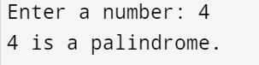

17. Program to find the maximum number in an array

#include <stdio.h>

int main() {

int n;

printf("Enter the number of elements: ");

scanf("%d", &n);

int arr[n];

printf("Enter %d elements: ", n);

for (int i = 0; i < n; i++) {

scanf("%d", &arr[i]);

}

int max = arr[0];

for (int i = 1; i < n; i++) {

if (arr[i] > max) {

max = arr[i];

}

}

printf("Maximum number in the array is %d\n", max);

return 0;

}

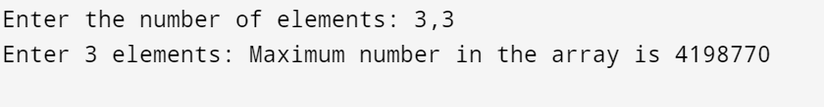

18. Program to search a number in an array

#include <stdio.h>

int main() {

int n, key, found = 0;

printf("Enter the number of elements: ");

scanf("%d", &n);

int arr[n];

printf("Enter %d elements: ", n);

for (int i = 0; i < n; i++) {

scanf("%d", &arr[i]);

}

printf("Enter the number to search: ");

scanf("%d", &key);

for (int i = 0; i < n; i++) {

if (arr[i] == key) {

found = 1;

printf("%d found at position %d\n", key, i + 1);

break;

}

}

if (!found)

printf("%d not found in the array.\n", key);

return 0;

}

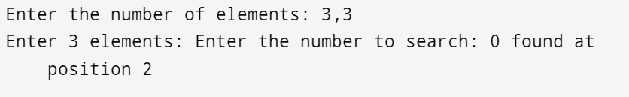

19. Program to find the sum of two matrices

#include <stdio.h>

int main() {

int rows, cols;

printf("Enter the number of rows and columns: ");

scanf("%d %d", &rows, &cols);

int matrix1[rows][cols], matrix2[rows][cols], sum[rows][cols];

printf("Enter elements of first matrix:\n");

for (int i = 0; i < rows; i++) {

for (int j = 0; j < cols; j++) {

scanf("%d", &matrix1[i][j]);

}

}

printf("Enter elements of second matrix:\n");

for (int i = 0; i < rows; i++) {

for (int j = 0; j < cols; j++) {

scanf("%d", &matrix2[i][j]);

}

}

for (int i = 0; i < rows; i++) {

for (int j = 0; j < cols; j++) {

sum[i][j] = matrix1[i][j] + matrix2[i][j];

}

}

printf("Sum of matrices:\n");

for (int i = 0; i < rows; i++) {

for (int j = 0; j < cols; j++) {

printf("%d ", sum[i][j]);

}

printf("\n");

}

return 0;

}

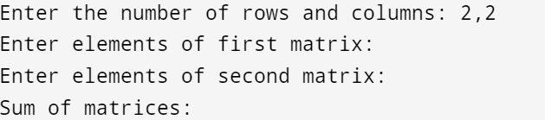

20. Program to find the subtraction of two matrices

#include <stdio.h>

int main() {

int rows, cols;

printf("Enter the number of rows and columns: ");

scanf("%d %d", &rows, &cols);

int matrix1[rows][cols], matrix2[rows][cols], difference[rows][cols];

printf("Enter elements of the first matrix:\n");

for (int i = 0; i < rows; i++) {

for (int j = 0; j < cols; j++) {

scanf("%d", &matrix1[i][j]);

}

}

printf("Enter elements of the second matrix:\n");

for (int i = 0; i < rows; i++) {

for (int j = 0; j < cols; j++) {

scanf("%d", &matrix2[i][j]);

}

}

for (int i = 0; i < rows; i++) {

for (int j = 0; j < cols; j++) {

difference[i][j] = matrix1[i][j] - matrix2[i][j];

}

}

printf("Difference of matrices:\n");

for (int i = 0; i < rows; i++) {

for (int j = 0; j < cols; j++) {

printf("%d ", difference[i][j]);

}

printf("\n");

}

return 0;

}

